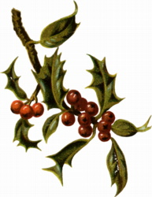

May your Christmas be jolly,
Full of holly,
And free from folly.

