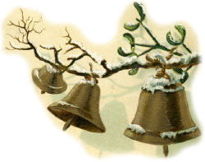

Let the Christmas bells ring!
Let the Christmas angels sing!
Isn’t Christmas time a wondrous thing?

