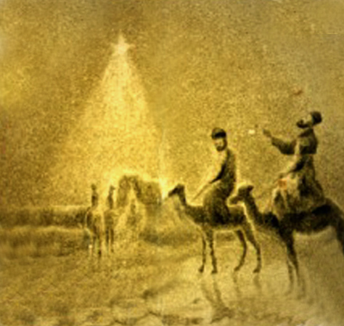

We have seen His star in the east,
and are come to worship Him!

