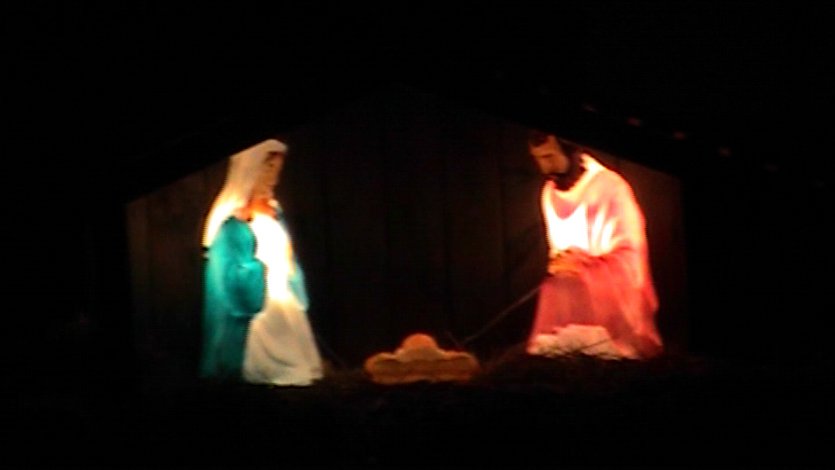

And she brought forth her firstborn son,
and wrapped him in swaddling clothes,
and laid him in a manger;
because there was no room for them in the inn…

