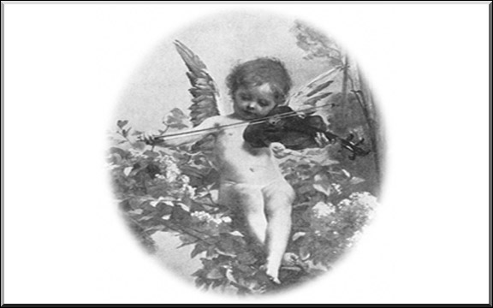

Hark! The Herald Angels play violin too.

