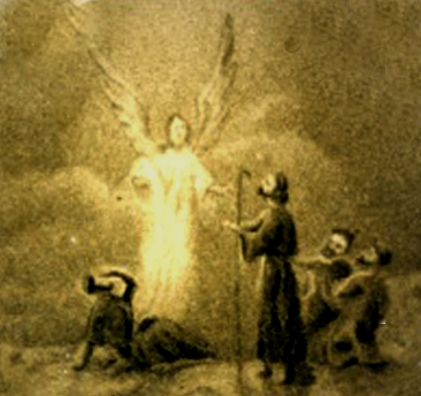

And lo,
the angel of the Lord came upon them,
and the glory of the Lord shone round about them:
and they were sore afraid.
And the angel said unto them,
Fear not: for, behold,
I bring you good tidings of great joy,
which shall be to all people.
For unto you is born this day
in the city of David,
a Saviour, which is
Christ the Lord!

